**ROTATE LEFT OPERATION**

**EXP NO: 18**

**AIM:**To compute rotation of given data in left without carry using 8085 processor. 

**ALGORITHM:**  
1)      Load the base address of the array in HL register pair.   
2)      Move the data from memory location into accumulator.  
3)      Shift left the accumulator content for four times.  
4)      Store the result in the specified location.  
**PROGRAM:**  
MVI A,02  
RLC  
RLC  
RLC  
RLC  
STA 2000  
HLT  
**INPUT:**  
  
  
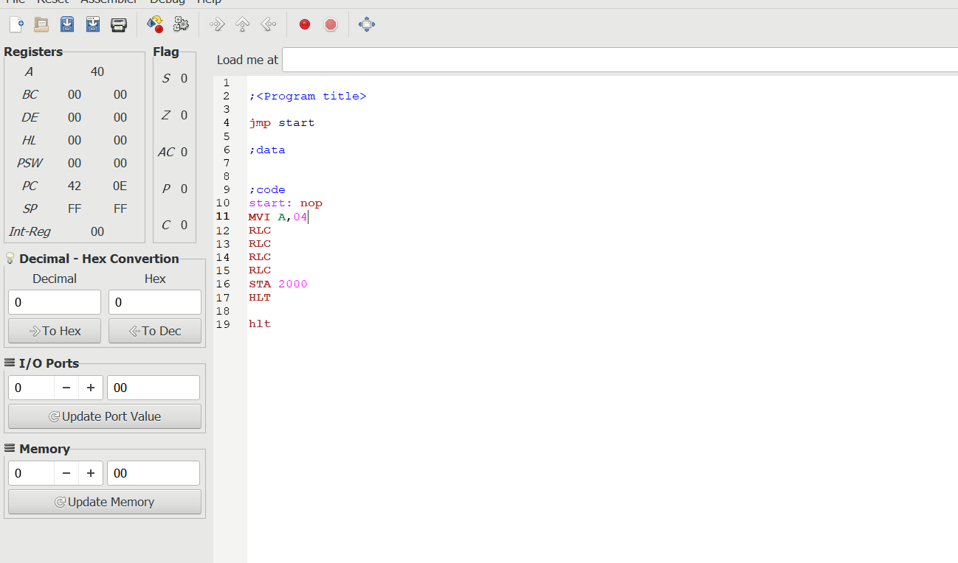  
  
  
 

**OUTPUT:**

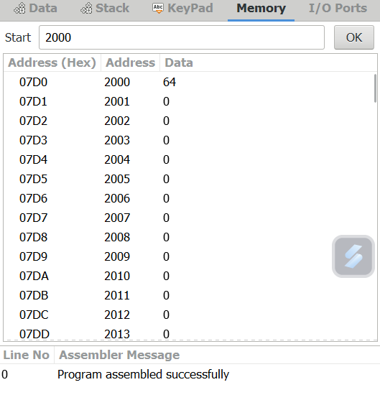  
  
  
  
  
   
  
  
  
  
  
  
  
  
  
  
  
  
**RESULT:**Thus the program was executed successfully using 8085 processor simulator.